Software Description: RideNED
Lab Session 08 - Open Ended Lab

System Name
RideNED

Purpose of the System
RideNED is a transportation management mobile application designed for NED University. The system aims to automate and digitize the university’s transport operations. It bridges the gap between students and the transport administration by providing real-time point tracking, digital passes, and streamlined communication for complaints and lost/found items.

Main Features
- Live Point Tracking: Real-time GPS tracking of university points with ETA updates and stop notifications.
- Digital Point Pass: QR-based monthly passes linked to student accounts, replacing manual ID checks.
- Digital Fee Payment: Integration with E-wallets and Bank Transfers for seamless point fee payments.
- Pre-Booking System: Allows students to book seats for department-specific or general industrial trips.
- Lost and Found Board: A centralized forum to report and claim lost items on campus transport.

Types of Users
- NED University Students: Users who utilize the app to track points, generate passes, pay fees, and report complaints. Requires valid university credentials.
- NED Admin: Administrators who manage routes, approve digital passes, monitor live tracking, and handle driver complaints via a backend dashboard.

Task 1: Software Description (LaTeX Source Code)

\documentclass{article}
\usepackage[utf8]{inputenc}
\usepackage{geometry}
\geometry{a4paper, margin=1in}

\title{\textbf{Software Description: RideNED}}
\author{Lab Session 08 - Open Ended Lab}
\date{}

\begin{document}
\maketitle

\section*{System Name}
RideNED

\section*{Purpose of the System}
RideNED is a transportation management mobile application designed for NED University. The system aims to automate and digitize the university's transport operations. It bridges the gap between students and the transport administration by providing real-time point tracking, digital passes, and streamlined communication for complaints and lost/found items.

\section*{Main Features}
\begin{itemize}
\item \textbf{Live Point Tracking:} Real-time GPS tracking of university points with ETA updates and stop notifications.
\item \textbf{Digital Point Pass:} QR-based monthly passes linked to student accounts, replacing manual ID checks.
\item \textbf{Digital Fee Payment:} Integration with E-wallets and Bank Transfers for seamless point fee payments.
\item \textbf{Pre-Booking System:} Allows students to book seats for department-specific or general industrial trips.
\item \textbf{Lost and Found Board:} A centralized forum to report and claim lost items on campus transport.
\end{itemize}

\section*{Types of Users}
\begin{itemize}
\item \textbf{NED University Students:} Users who utilize the app to track points, generate passes, pay fees, and report complaints. Requires valid university credentials.
\item \textbf{NED Admin:} Administrators who manage routes, approve digital passes, monitor live tracking, and handle driver complaints via a backend dashboard.
\end{itemize}

\end{document}

Task 2: (UML Modeling)

SEQUENCE DIAGRAMS

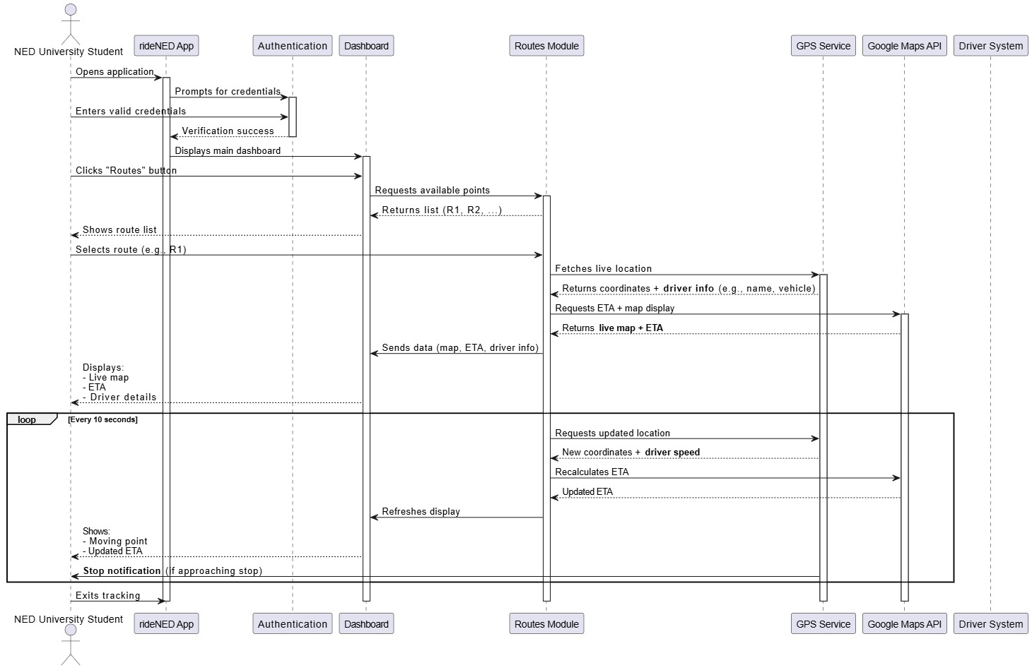
System Feature: University Point Tracking System

System Feature: Digital Point Pass

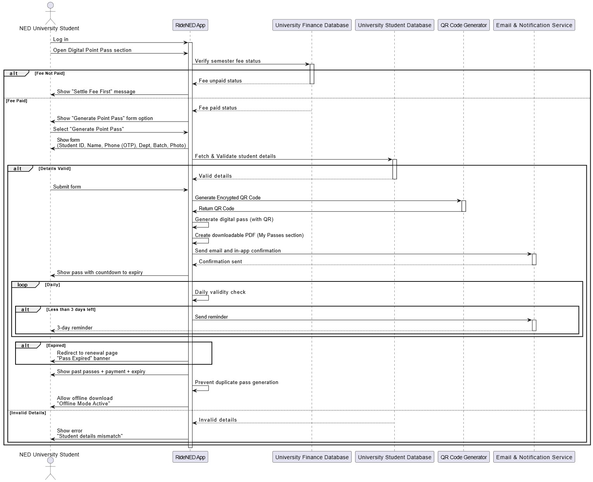

Task 3: (User Interface Prototype)

Registration Interface for Driver, Head of Department, and Admin
The registration interface allows the Driver, Head of Department (HOD), and Admin to create an account using their allocated credentials. The interface includes input fields for username and password, along with “Forgot Password” and “Remember Me” options to assist in credential recovery and user convenience.

Login Interface for Student, Driver, Head of Department, and Admin
The login interface provides secure access to the system for Students, Drivers, Heads of Department, and Admins. It contains two primary input fields, email and password, along with “Forgot Password” and “Remember Me” options to support account recovery and session management.

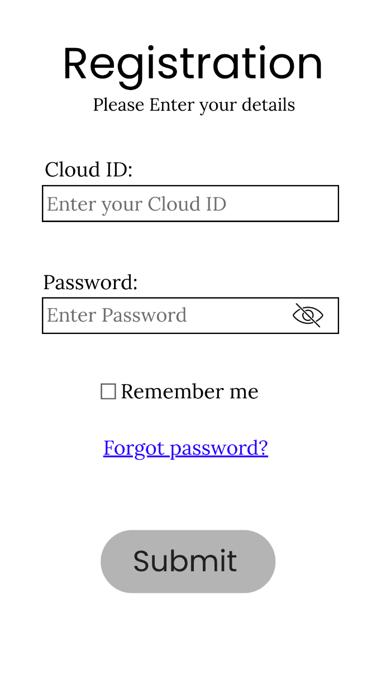
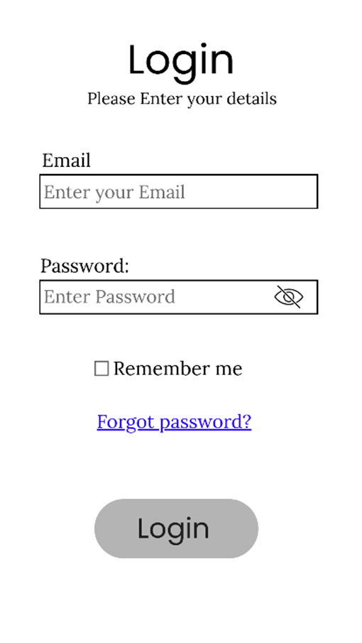
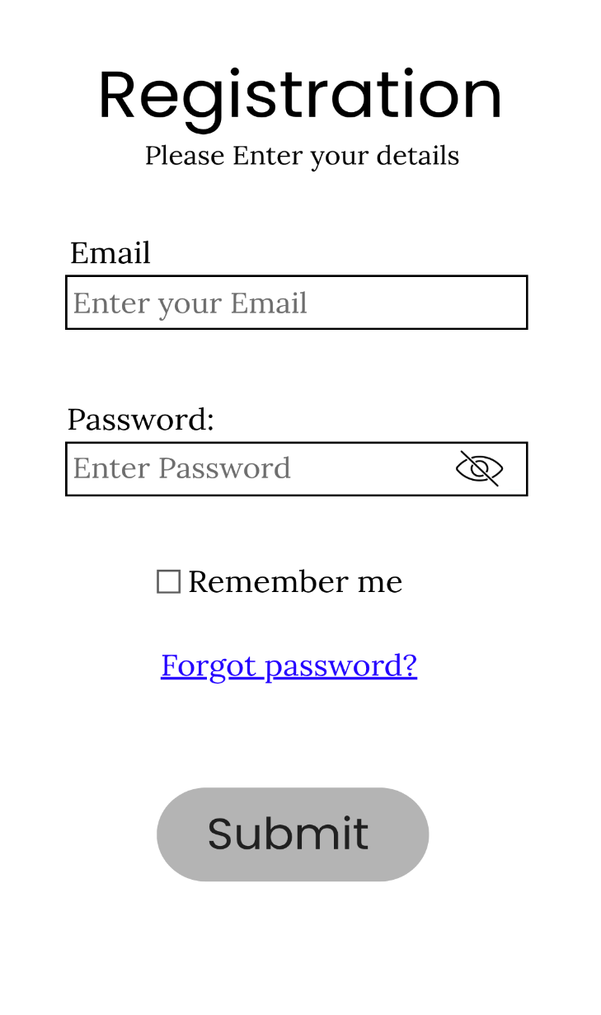

Dashboards Overview
Driver Dashboard
Driver Dashboard serves as the central hub for all driver-related operations. The interface includes options to:
- View active points
- Make announcements regarding delays or schedule changes
- Access Digital Pass for attendance
- Report or view lost and found items
- File complaints or request assistance
- View schedule
Driver can also view notifications, manage profile, and request assistance from the menu bar.
Admin Dashboard
The Admin Dashboard provides access to core administrative functions. Admins can:
- View active points
- Handle complaints and feedback
- Book trips
- Make announcements visible to users
- View lost and found items
- Manage driver schedules
Admins can also view notifications, history, all digital passes, and manage their profile from the menu bar.
Student Dashboard
The Student Dashboard provides a visual overview of available services. Students can:
- Access the Digital Pass section to view or generate their pass
- Make payments for pass renewal or fees
- Report issues or emergencies
- View notifications and points lists
- Check history

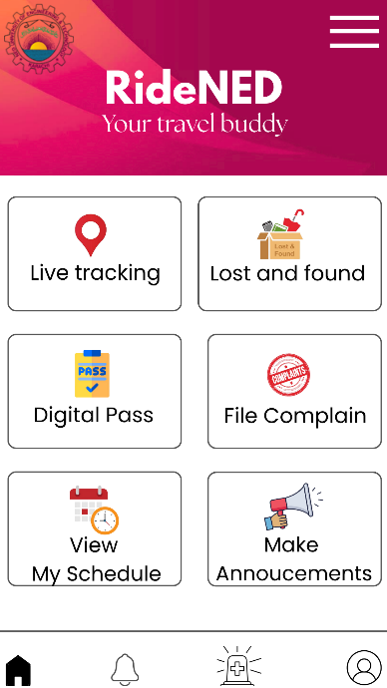
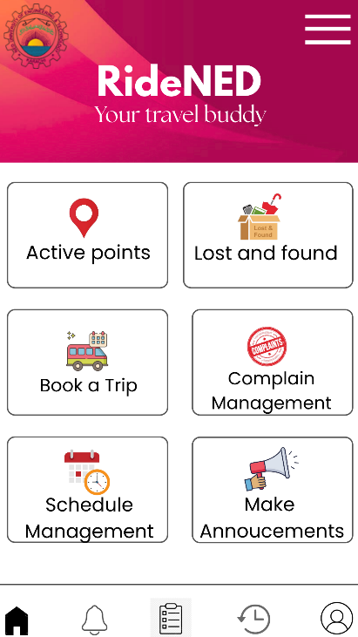
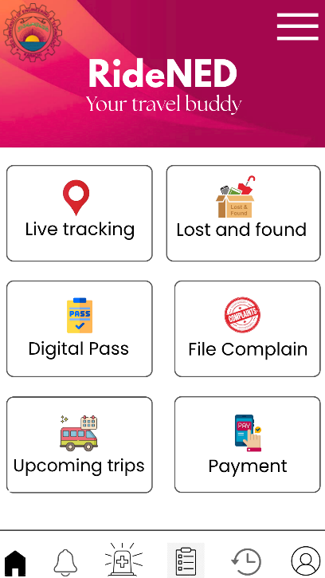

LIVE TRACKING FOR STUDENTS AND ADMIN INTERFACE
The live tracking interface provides a real-time map view that allows both students and administrators to monitor the movement of the point. Through this interface, users can track the point as it follows a selected route, view nearby points, and observe the estimated time of arrival (ETA). All tracking information is updated dynamically to ensure accurate and real-time visibility.

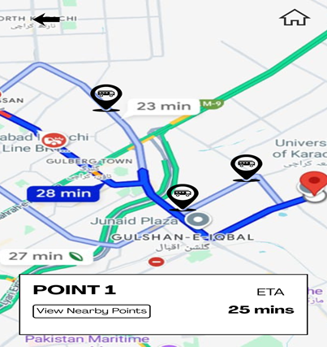
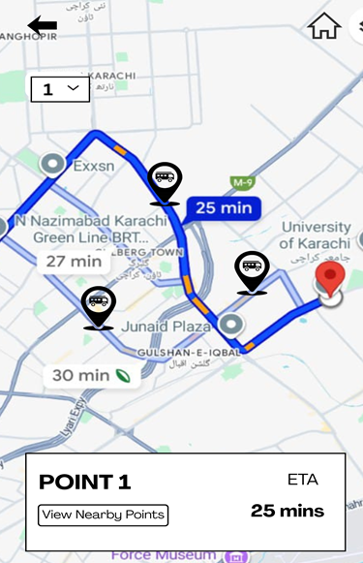
z

Task 4 – Design Concept Identification
Design Pattern Identified: Observer Pattern
Possible Use in RideNED System:
The Observer Pattern is ideal for the Live Point Tracking and Notification System within the RideNED application.
Implementation Concept:
- The university point's GPS location service acts as the Subject (state owner).
- The students' mobile applications act as Observers (dependents).
How It Works:
Instead of having thousands of student apps constantly query the server for the bus location (polling), the Observer Pattern provides an efficient, event-driven solution.
- When a student clicks "Notify Me" for a specific stop, their app subscribes to that stop’s route.
- The GPS tracker (Subject) updates its location state in real-time.
- If the estimated arrival time (ETA) is under 5 minutes, the system automatically sends a notification to all subscribed Observers.
Benefits:
- Decouples the GPS module from the user interface.
- Reduces server load and database queries.
- Ensures students receive real-time, accurate notifications efficiently.

